AutoEmail Full Installation Tests
Tester: Tony Tasker
Date: 9th January 2017
Time: 14:00
PC/Server: TonyTasker-PC
Database: CABS_TEST (Copy of SHU DB)
Works Summary: N/A
Works Order: N/A
Task: N/A
Notes: These tests were performed using Microsoft SQL Server Management Studio. Output to the Results and Messages Output Windows are used to determine the success of the tests. Also the receipt of emails.

Testing change to emails AEFPBK and AEFFFC to ensure that the Function Date and not the Event Start Date is added to the Subject Line.

Pre-Test Setup
No | Task | Tester | Pass | Notes
1 | In X CABS Config, Section CABS_AUTO_EMAIL_FUNCS if WIPWindow is set then  WIPWindow=0  Set DebugFlag=1  In section CABS_AUTO_EMAIL_FUNCS_Trigger  Set DebugFlag=1 | TT
2 |  | TT

Post-Test Setup
No | Task | Tester | Pass | Notes
1 | Reverse any Config Changes in X CABS Config | TT

Tests

Feedback Form from Customer Email – AEFFFC
No | Test | Tester | Pass | Notes
1 | In CABS locate a function to test with:  SELECT F_MBR_NO, F_REF, F_DAY FROM FUNC_FIL WHERE F_STARTDATETIME < GETDATE()  GROUP BY F_MBR_NO, F_REF, F_DAY  Using F119328, M015361  Ensure correct classification  SELECT * FROM AC10 WHERE AC_OWNER = 'M015361'  Should return a record with AC_CODE = HELP - if not add/update a record  UPDATE AC10 SET AC_CODE = 'HELP' WHERE AC_OWNER = 'M015361'  Ensure following settings are set in System Defaults, Section AEFFFC:  ClassConstraint1 = 1  SendToBooker=0  SendToClient=0  SendToContact=1 | TT |  | Need to find a function which is part of an MBR with multiple functions on it. Do not pick the first function as it will have the date as event start date.
2 | Update the status of the Function to CONFRM  UPDATE FUNC_FIL SET F_STATUS = 'CONFRM' WHERE F_REF = 'F119328'  Check status of AutoEmail Queue  SELECT * FROM vw_AEFLINK WHERE AEFL_FREF = 'F119328' | TT |  | For Email Template AEFFFC:  AEFL_CanSend should be 1,  AEFL_Sent should be 0,  SessionSendable should be 1,  Sendable should be 1,  MatchCriteria should be 1
3 | Process the AutoEmail  EXEC CABS_AUTO_EMAIL_FUNCS_SESS_CHECK | TT |  | Email delivered as per Figure 1
4 | Check the function date is different from the  event start date and the function date is on the subject line  SELECT F_DAY FROM FUNC_FIL WHERE F_REF = 'F119328'  SELECT MBR_FROM FROM MBRFILE WHERE MBR_SYSNO = 'M015361' | TT |  | Function date is 25/07/2016 and Event date is 25/05/2016

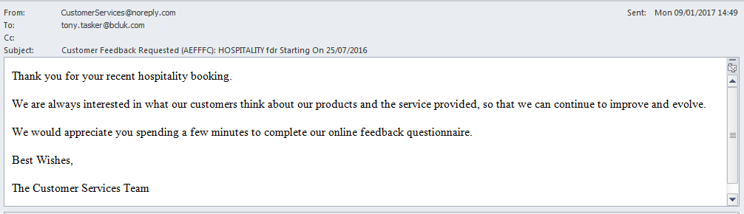
Figure 1 – Feedback From Customer Request AutoEMail

Provisional Booking Email – AEFPBK
No | Test | Tester | Pass | Notes
1 | In CABS locate a function to test with:  SELECT F_MBR_NO, F_REF, F_DAY FROM FUNC_FIL INNER JOIN MBRFILE ON F_MBR_NO = MBR_SYSNO WHERE F_STARTDATETIME > GETDATE() AND COALESCE(MBR_SYSNO, '') <> ''  GROUP BY F_MBR_NO, F_REF, F_DAY  Using F119256, M015623  Ensure correct classification  SELECT * FROM AC10 WHERE AC_OWNER = 'M015623'  Should return a record with AC_CODE = HELP - if not add/update a record  UPDATE AC10 SET AC_CODE = 'HELP' WHERE AC_OWNER = 'M015623'  Ensure following settings are set in System Defaults, Section AEFPBK:  ClassConstraint1 = 1  SendToBooker=0  SendToContact=1  SendToDepartment=0 | TT |  | Need to find a function which is part of an MBR with multiple functions on it. Do not pick the first function as it will have the date as event start date.
2 | Change the status of the Function to Provisional  UPDATE FUNC_FIL SET F_STATUS = 'PROVNL'  WHERE F_REF = 'F119256'  Check status of AutoEmail Queue  SELECT * FROM vw_AEFLINK WHERE AEFL_FREF = 'F119256' | TT |  | For Email Template AEFPBK:  AEFL_CanSend should be 1,  AEFL_Sent should be 0,  SessionSendable should be 1,  Sendable should be 1,  MatchCriteria should be 1
3 | Process the AutoEmail  EXEC CABS_AUTO_EMAIL_FUNCS_SESS_CHECK | TT |  | Email delivered as per Figure 2
4 | Check the function date is different from the  event start date and the function date is on the subject line  SELECT F_DAY FROM FUNC_FIL WHERE F_REF = 'F119256'  SELECT MBR_FROM FROM MBRFILE WHERE MBR_SYSNO = 'M015623' | TT |  | Function date is 15/07/2018 and Event date is 13/07/2016

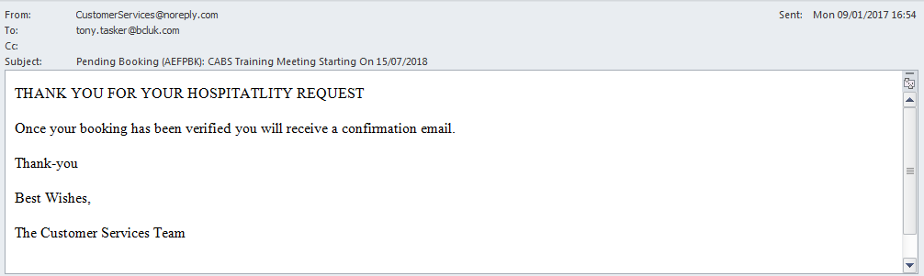
Figure 2 - Provisional Booking AutoEMail – Sent to MBR Contact

